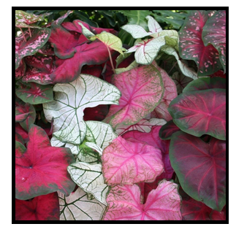
GORGEOUS!!
Potted Caladium Plants Fundraiser
- Who? Lakemoor Hills Garden Club
- When? Order now / May delivery
- Cost? $5 each or 5 pots for $20
Proceeds will support neighborhood beautification, including the Legacy Park and roundabout plantings

Big, healthy bulbs will be lovingly planted by Garden Club volunteers. Sprouted bulbs in
4” pots will be available for pick-up or delivery in mid to late May. This special offering will be
made to BOTH residents and non-residents of Lakemoor Hills so ORDER EARLY!!

Growing Tips: Caladiums are easy to grow in landscape beds as well as containers. Sprouted plants should be placed 4-6” apart in moist, well-drained soil. They prefer partial shade and will grow best where protected from harsh sunlight and wind. They will appreciate a little bone meal or 6-6-6 fertilizer at planting and every month or so during the growing season. Containers should be checked regularly for adequate moisture – especially if exposed to direct sunlight. Caladiums in mulched beds should receive weekly watering if there is not adequate rain. Great companion plants: begonias, ferns, impatiens, and coleus. Questions? Call Fran Thomforde: 865-621-2418
 
Order Form
Reserve your caladiums HERE:

Today's Date: _________ (if we run low on particular colors, requests will be filled in the order received)
NAME:

BEST PHONE # ADDRESS:

Mail or drop off your order form and check (made out to "Lakemoor Hills Garden Club")
to: Fran Thomforde
3616 Circle Lake Ln.
Knoxville, TN 37920
* You will be called / emailed when plants are ready for pick-up or delivery.
EMAIL:
Specify number and type of plants desired:
Quantity: ________ Red Fancy Leaf
Quantity: ________ White/Freckled Fancy Leaf
Quantity: ________ Pink Fancy Leaf

TOTAL number of plants ________
@ $5.00 each or 5 plants for $20. TOTAL AMOUNT FOR CHECK $

